Network modelling of cancer progression

Document structure
This worksheet is split into two stages. The first section is a pre-activity that introduces the cancer biology, specifically discussing how healthy cells progress to become cancerous. This is followed by the main activity where students work with a real biological model and answer a set of questions by altering the model.

What is cancer? (or ‘what makes a good cell turn bad?’)
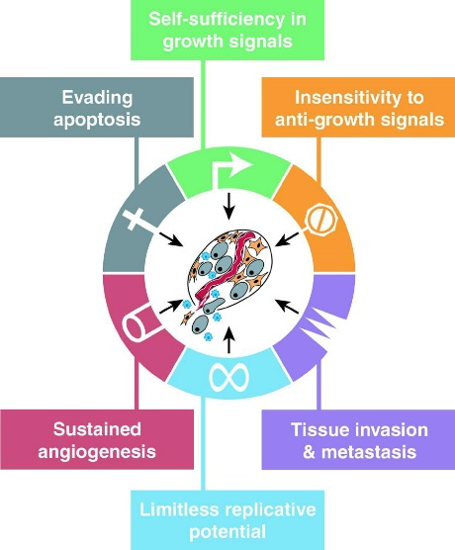
Cancer is a disease caused by cellular malfunction. Rare errors that occur within cells in the body cause their behaviour to change, and these changes in behaviour drive the transformation of cells from a healthy state to the disease state.
The hallmarks of cancer represent key biological behaviours associated with cancer cells. As a cancer progresses, the control on each of these processes is lost allowing the tumour to grow and to metastasise. All of these behaviours have important roles in healthy cells; it’s the loss of control that defines the disease.

The errors in cells that can drive cancer forward fall into a set of well-defined categories, known as the “Hallmarks of Cancer”. These relate to different aspects of the cancer progression. Crucially, all of these behaviours are important to the life of a healthy cell. The key difference between healthy and cancerous cells is the loss of control. This allows cells to ignore signals from other cells, to grow quickly, and ultimately to metastasise to other tissues in the late stages of the diseases.
https://en.wikipedia.org/wiki/The_Hallmarks_of_Cancer
https://doi.org/10.1016%2Fj.cell.2011.02.013

Uncontrolled Growth
One key hallmark is that individual cells start growing too quickly, and ignore signals from their neighbours to stop growing. Cell growth is normally determined by a wide range of external signals and controls. Healthy cells may respond to growth factors that cause the cell to divide, and to other signals (such as tight cell packing) to slow or stop the growth. Cancer cells may produce their own growth factors, or have defective (mutated) membrane proteins that trigger growth in the absence of signal. This uncontrolled growth is a key feature of cancer and is necessary for the development of the tumour.

Apoptosis
Once errors start to accumulate, cells detect this and “apoptose”- they commit a programmed cell suicide, in a mechanism that helps avoid cancer development. This process has other uses in the body- it helps separate tissues and so create structures. However, DNA damage in the cell causes the cell to stop growing, and if the damage cannot be repaired, to commit suicide to minimise the danger to the body. Another hallmark of cancer is therefore that cells lose this ability to commit suicide, and so can continue to accrue mistakes.
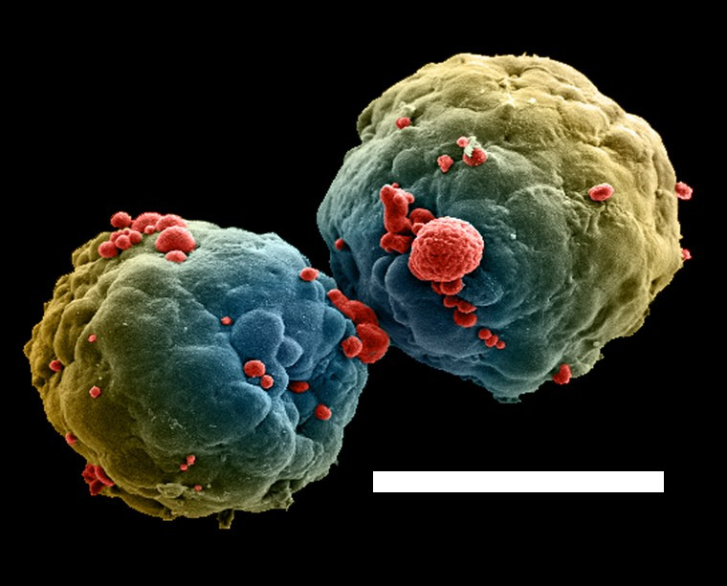
A cluster of breast cancer cells grown in a laboratory. Cells in red on the surface are undergoing apoptosis in response to a drug treatment. Scale bar = 250 μm
Credit: Izzat Suffian, David McCarthy & Khuloud T. Al-Jamal CC-BY https://wellcomecollection.org/works/bx4777dc

Angiogenesis
Once a tumour gets to a certain size, cells in the middle of the tumour can become nutrient starved, slowing the growth. Another hallmark is for the tumour to encourage the growth of blood vessels – angiogenesis - to supply nutrients to enable the tumour to continue growing. The nutrient starvation can also cause other metabolic changes in the cell, as the cell starts scavenging for biomolecules to keep growing.

Metastasis
The final stage of cancer is metastasis, where cells break off from the original tumour and circulate around the body, invading other tissues and starting new tumours. This requires the cells to detach from the primary tumour, survive in blood or lymph vessels, and then to invade other tissues. The specific tissues that a cancer preferentially invades vary with cancer type, though the first site for cancer metastasis is typically the lymph node. It has been suggested that this is because factors flowing off the tumour (for example, metabolites) and into the lymph vessels prime the lymph node for cell invasion, before the process of metastasis has begun.
https://doi.org/10.1038/ni.3492
Lymph nodes respond to nearby tumours by changing their size, shape, and internal structure. Images are taken before, 4 and 11 days post exposure to a tumour. Different coloured stains show different types of cells, and including changing numbers of (red) immune cells. It is believed that these internal changes promote invasion by cancer cells. Scale bars 200 μm
All these cellular behaviours are ultimately controlled by proteins in the cell. In healthy cells these proteins act in concert to ensure that they only carry out their functions under tight controls. Errors however turn individual proteins off or on driving the cancer forward. A gene whose inactivation leads to tumour development is known as a tumour suppressor, whilst a gene whose activation leads to cancer is an oncogene. This activity will allow you to explore a network “model” (a mathematical representation of the cell) of how these genes work together to control cellular behaviour, and how drugs work to counteract the faulty genes. A simulation of a model shows how the model changes over time from a known starting condition. We will use simulations and other types of analysis to see how mutations change the cell, how they can work together, and why certain drugs are effective for some but not all cancers.

Activity
At the end of this activity you should be able to:
- Show how the loss of individual genes changes cell behaviour
- Understand how multiple genes work together
- Become competent in using biological network modelling towards the A level practical endorsement

Instructions
Getting started- opening a network model
- Open the model of cancer signalling in BioModelAnalyzer through this link: http://biomodelanalyzer.org/tool.html?Model=preloaded/CancerSignalling.json
- Click on the model operations tab on the left
- Click save to store a version of this model in your own repository. Any changes you make now can be saved here. If you want to rename your model, click on the name (“CancerSignalling” here) and rewrite.
- All your saved models can be found by clicking the “Models” button. Clicking on a model will open it, whilst clicking the trash can will delete it. Models are normally stored in the web browser cache.
- To share your model, click export to save it to disk. Saved models can be opened by importing with the import button.

Viewing and analysing the model
- The canvas in the middle of the screen shows your model. This model consists of a cell (the orange circle) with intracellular proteins (red), membrane proteins (green), and extracellular drugs (grey). The membrane (orange) acts as a barrier between the cell contents and the rest of the environment, preventing many molecules from entering and leaving the cell. Membrane proteins respond to signals from outside the cell, allowing the cell to change its behaviour depending on its environment and the information passed to the cell from its neighbours. Drugs act by inhibiting (turning off) protein activity and can either interact directly with membrane proteins, like cetuximab, or must cross the membrane to interact with proteins in the cell, for example trametinib.
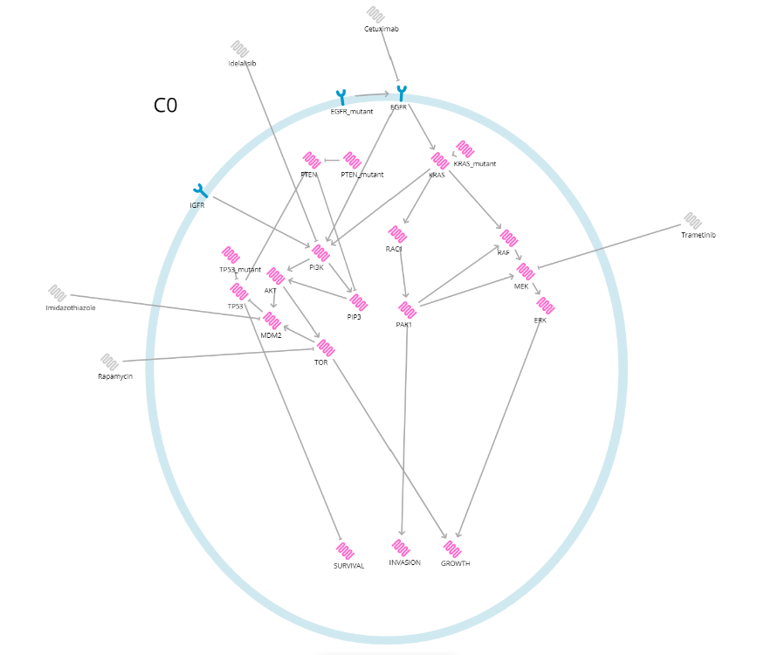
- In addition to the different proteins there are “mutant” switches attached to the PTEN, TP53, KRAS, and EGFR proteins. These simulate the errors that occur to drive cancers forward. Some of these mutations may cause the proteins to lose their activity, whilst others may cause proteins to become over active.
- Arrows between proteins show how proteins activate (pointed arrows) and inhibit one another
- Arranged at the bottom of the cell are three hallmarks of cancer; Survival, Invasion, and Growth. These behaviours change depending on the activity of proteins in the cell and are sensitive to cancer causing mutations.
- To move around the canvas, click the pan & selection tool and drag on empty space. Undo or redo any mistakes you make!
- Zoom into parts of the model with the zoom buttons, or use the mouse wheel to zoom automatically.
- To test your model, use the buttons on the right-hand side of the screen. Clicking the button at the top of the column will apply stability analysis to see how the model behaves. Stability analysis tells you how all possible simulations end- if you can prove your model is stable then it means that all simulations end with one set of values. If the model is stable, this test will put a number next to every protein, drug, and behaviour in the model. This is the stable state- the state that every simulation ends at. In this model, if a protein is equal to 1 it has been turned on; whilst a protein equal to 0 is inactive.

Exploring how cancer mutations change cell behaviour
- At first the model has no mutations. Test for stability as described above, and write down the states of the individual genes in the model (i.e. the numbers next to each gene). The hallmarks of cancer (SURVIVAL, INVASION, GROWTH) and the genes that lead directly into them are the most important to record, as later we will look to see how they change in cancer progression.
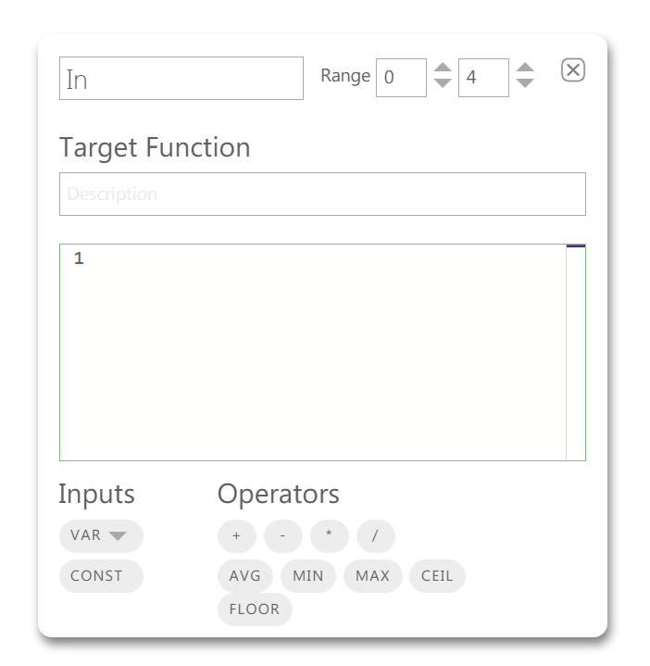
- Errors in PTEN and KRAS both promote the development of cancers. To see how these errors change the cell right click the PTEN_mutant and KRAS_mutant proteins and change the value in the target function box from 0 to 1
- Retest the model using stability analysis. The model is still stable but the state (the specific numbers associated with each gene) has changed. Record how each mutant changes the values of the genes that you observed in step 1, and note how the effect of the mutations propagate across the network to alter cell behaviour.

Questions
- MDM2 is an oncogene. That means it can become more active and cause cancer. Based on the network, how would it do this?
- KRAS is an important oncogene- how does it change individual proteins and the behaviour of the cell?
- List which drugs would be effective, partially effective, or ineffective against a cancer with a KRAS mutation? How would they perform against a PTEN mutation? Why do different drugs have different effectiveness?
- Thinking about the hallmarks of cancer, which mutation would you expect to be first in the development of cancer out of TP53 and KRAS? Give your reasoning
- Pathways that involve ERK and TOR are known to be important in breast cancer. Its been suggested that there might be feedback between the two proteins. If you add activating arrows between either or both of these proteins, how does this change the way that the model responds to cancer mutations? Do drugs work the same way for mutations with and without these interactions?

